**Knowledge Discovery Management Project**

**Increment-1 Report**

**Social Trend Analysis**

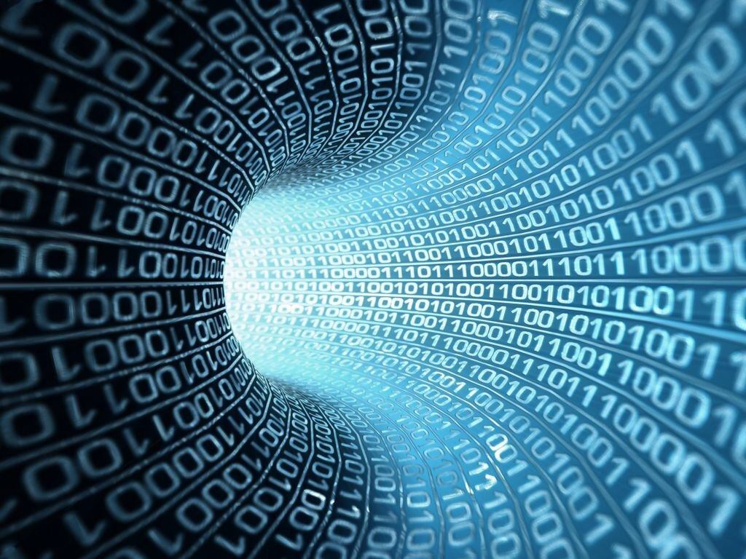

**Team:**

**Ashok Rudraraju,**

**Aditya Deshpande,**

**Tej Kiran Meka,**

**Mahesh Vemula.**

In this increment we have developed code for pulling the data of tweets from twitter. We have designed the basic User Interface required for our project. Currently we are analyzing the data to filter the unwanted data from the data pulled.

Below are few screenshots of the script and data of our project.

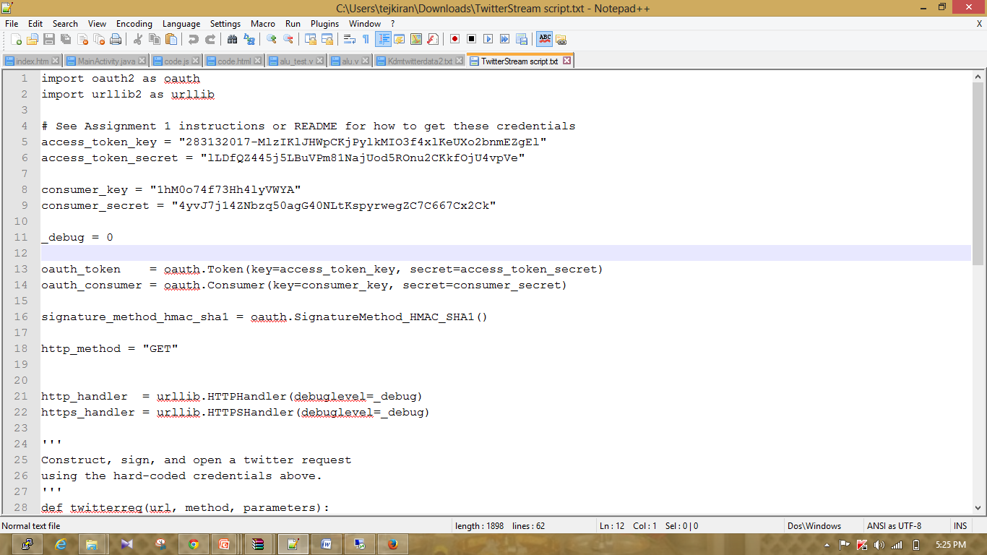

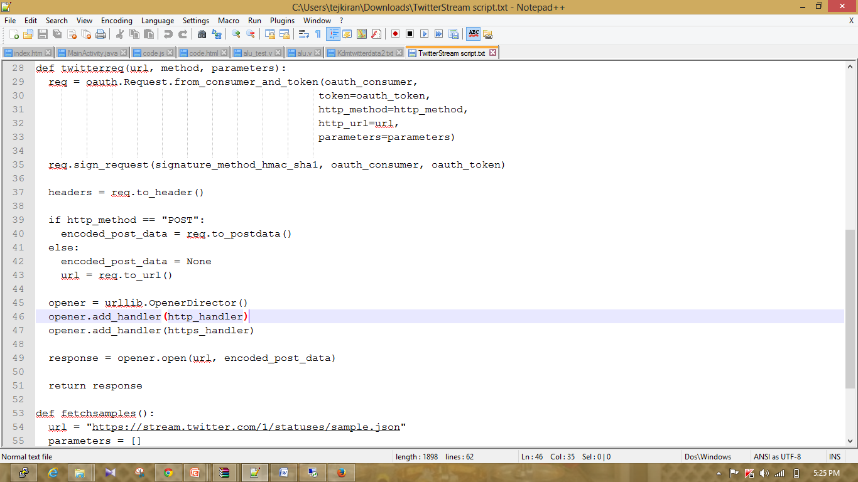

Above screenshots represents the script that we have developed to pull data from twitter.

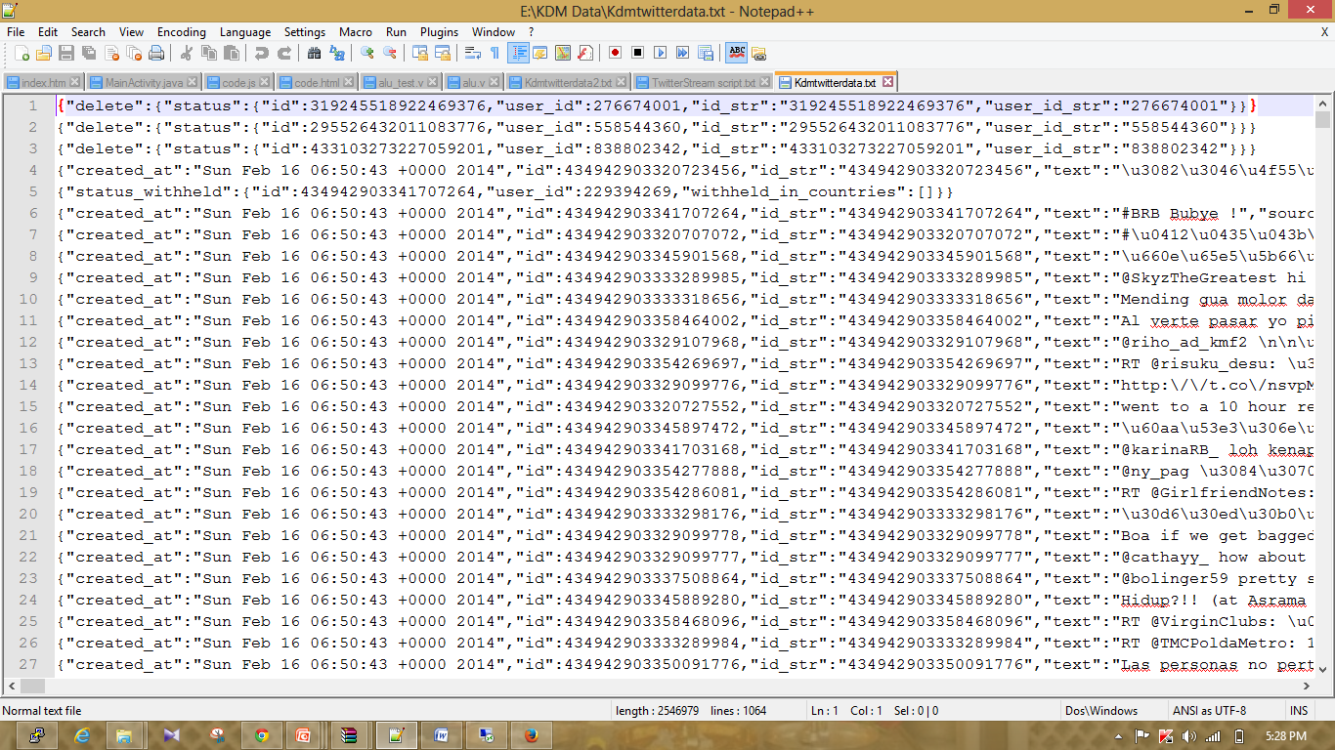

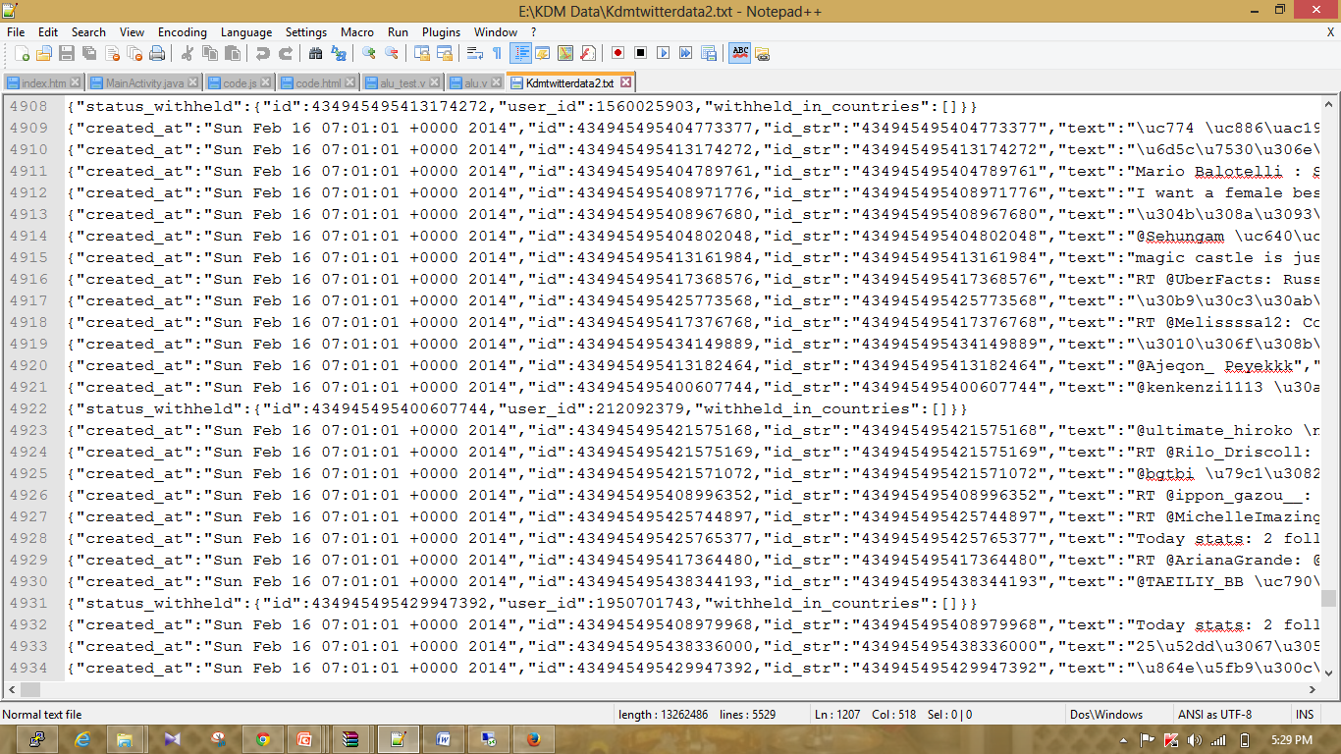

Above Screenshots represents the data that we have pulled from twitter. We pulled data around 2GB from twitter. Now we will are analyzing the data to filter out the unwanted data.

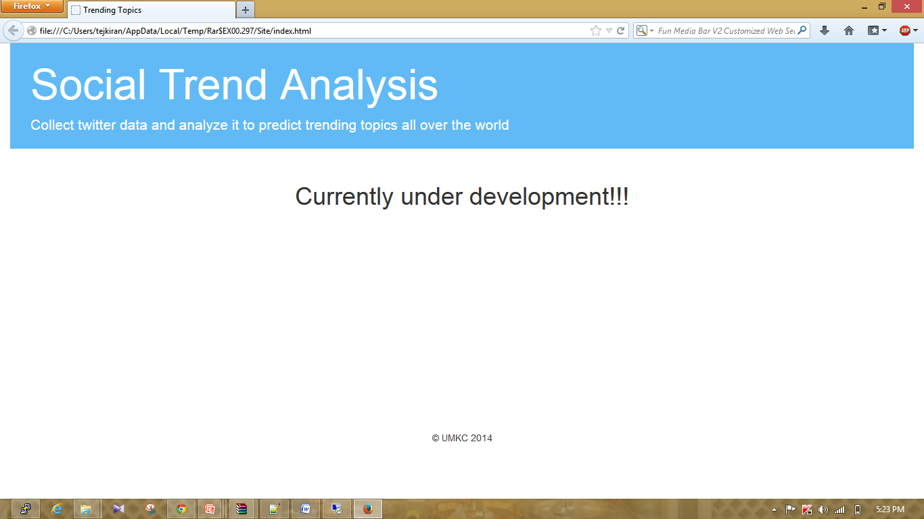

The above screenshot represents the basic UI that we will be implementing for this project. We are using Twitter Bootstrap for UI in this project. We are following Web based approach for this project.

**Roles for the 1st Increment:**

**Ashok Rudraraju, Tej Kiran:** Script for pulling the data, Analyzing the data.

**Aditya, Mahesh:** UI of the project, Analyzing the data.

**Issues Faced:**

Experienced few bugs and authentication issues while pulling data.

Unable to host the website to UMKC cloud.

Unable to connect to UMKC cloud from personal network. But we are able to connect to UMKC cloud through UMKC network.

**Work to be done:**

Currently we are analyzing the data and we are developing the code to filter out the unwanted data from the raw data pulled from twitter.